First of all I’d like to introduce myself, I’m Paul with my Son and his wife we have a 100 acre farm in Suffolk. What is known as a mixed farm, a few cattle, grassland and arable growing barley, oats, field beans and of course wheat. The wheat we grow is cut with a binder, shocked, left for a week or so and then carted and stacked just as it would have been prior to the advent of the combine harvester. We grow Squareheads Master and New Harvester with a bit of Atle spring wheat for flour production. As we only have about 70 acres of arable we can only grow about 20 acres of wheat at the most as we like to follow beans which must have at least a 3 year gap in the rotation.
My first experience using a binder was in about 1968 or 1969, here I am on a Massey Ferguson 135 pulling a Deering 5 foot cut binder.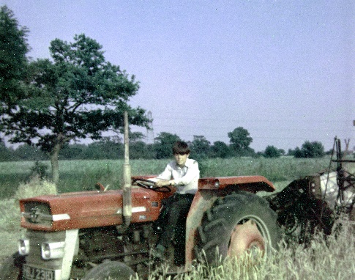 My father and his uncle didn’t have a great deal of shed space to store corn so they always had a wheat stack under thatch even though they had a combine since the mid 1950’s, an International Harvester B64 trailed combine.
In around 1973 a fire destroyed many of the buildings and being under insured my great uncle couldn’t afford to rebuild, so more wheat was cut with the binder and stacked as a method of storage. At this time the only thatching we knew about was the thatching of our stacks to protect them from the weather.
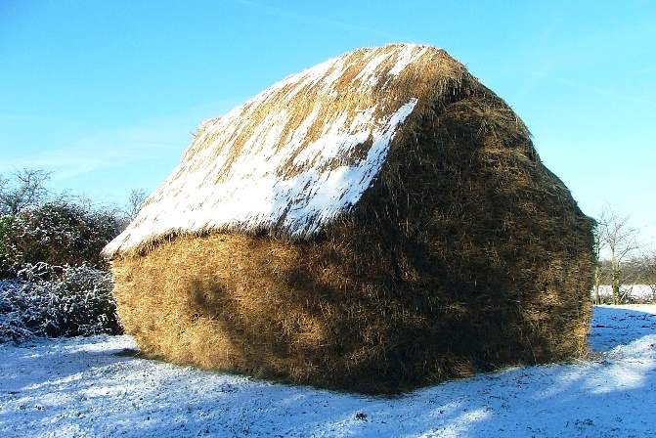
In around 1979 we had a visit from a local thatcher who rode up on his moped, he offered to buy the straw that we had recently threshed. This was a revelation to us as we were not particularly well off and just by chance this new income source happened which was a great help as my father was still paying off some inheritance tax after the death of his uncle. This “Out of the Blue” meeting with this moped riding thatcher opened the door to us to seek out older taller varieties than the Aquilla and Flanders we were growing at the time. Soon word got out and we had phone calls from other thatchers desperate for straw. As I understand it the late 60’s through to the late 70’s was not an easy time for the thatching industry as wheat got shorter and binders and threshing machines were hardly used at all. So for me coming into farming with my father at that time and knowing how to use the machinery was a big help.
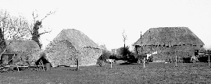
There we are, that’s my background. We continued to grow between 15 and 20 acres for years, selling straw mostly in Suffolk and South Norfolk but also to Hampshire and even as far as Ireland and South Uist off the Scottish coast.
Then around 15 years ago I was approached by a grower and a thatcher and grower about the formation of an association for thatching straw growers, this seemed like a good idea, there would be an inaugural meeting in Suffolk at the Laxfield Low House pub, 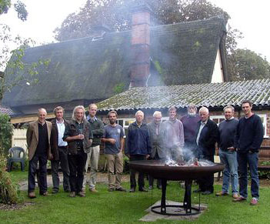
and then a larger meeting in Oxfordshire, hopefully things would take off. Some of you might have been there.
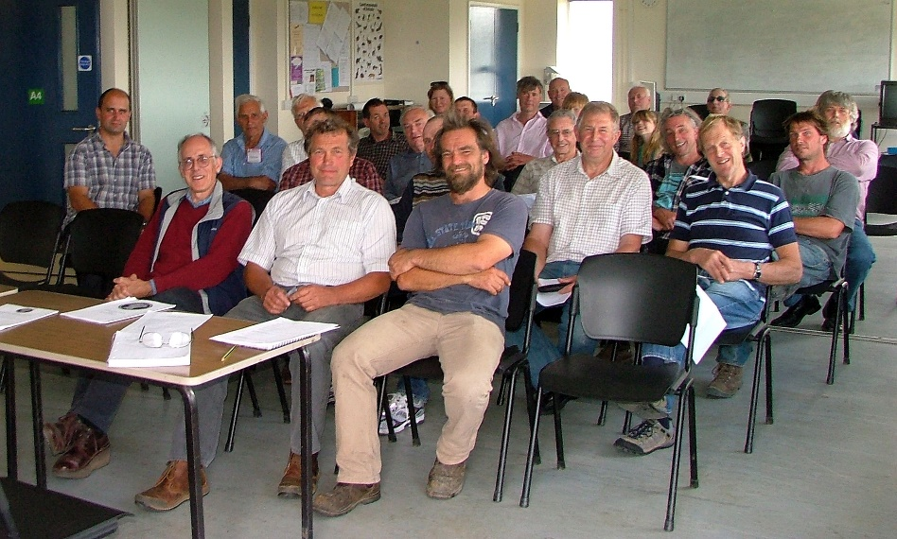
I felt that this was an opportunity to get to know other farmers who grow straw for thatching and exchange views and perhaps meet up occasionally and visit places of interest. I had no intention of becoming an officer on the committee let alone becoming Chairman.
Since the beginning we have been to the wheat variety plots at the John Innes Centre, Norwich. 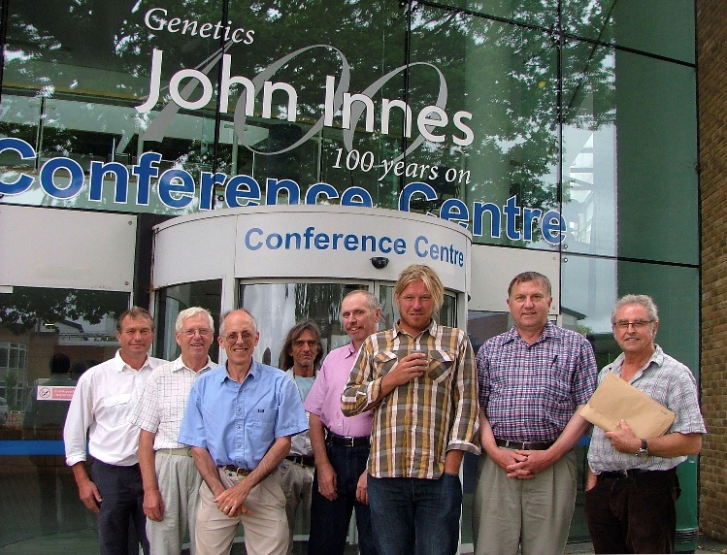 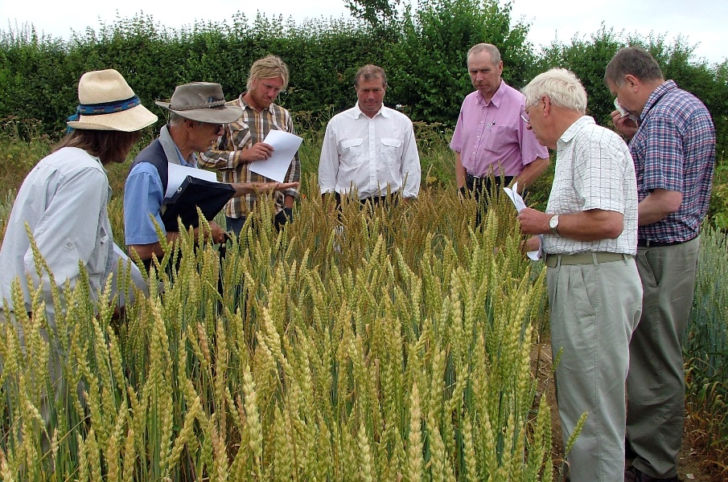

Wakelyns Agroforestry at Fressingield in Suffolk, 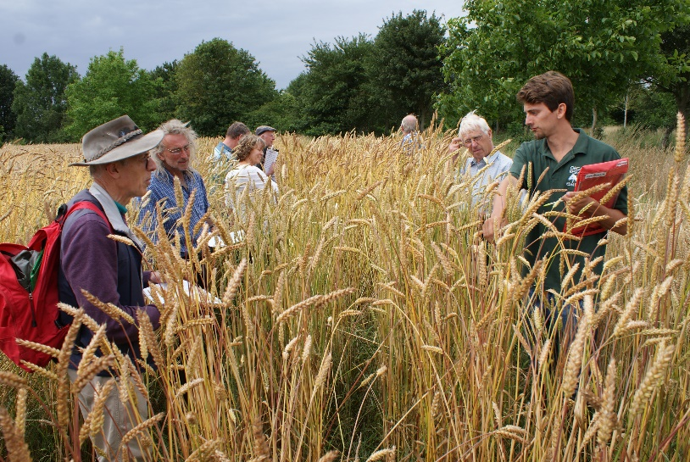
NIAB, the National Institute of Agricultural Botany Innovation Farm in Cambridgeshire, 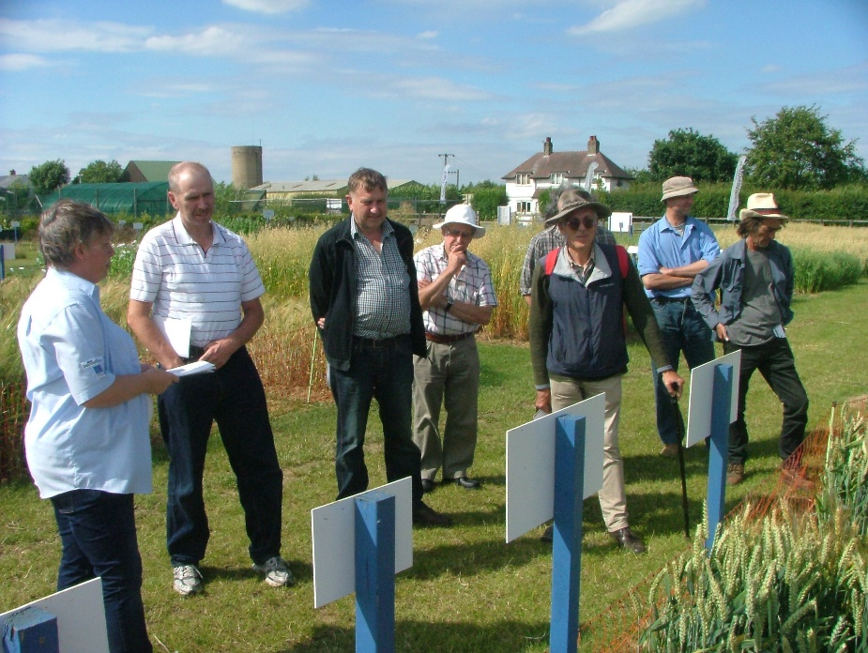

and the Enterprise Centre at the University of East Anglia, which has outside walls clad in straw thatch.
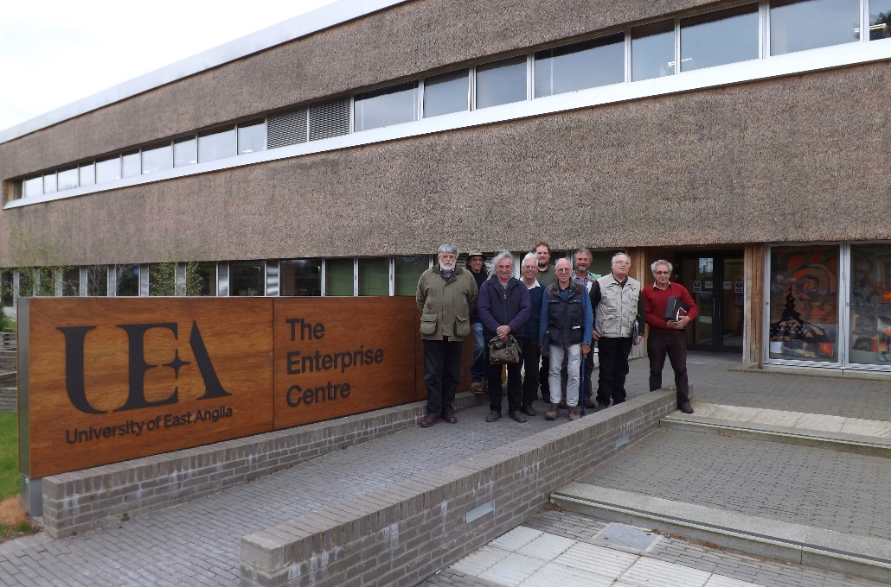

And a visit to our own place where we have the variety and husbandry project that the NTSGA and Historic England are working on together.
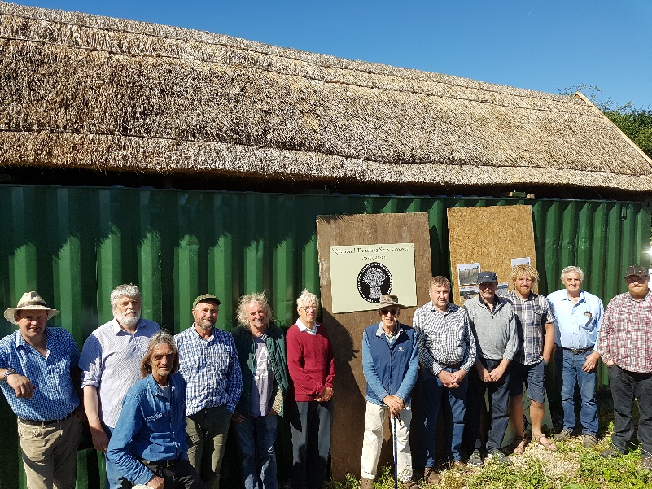
The project started in 2013 with growing five varieties of wheat under three different husbandry conditions, in our case residual nitrogen after a crop of field beans, 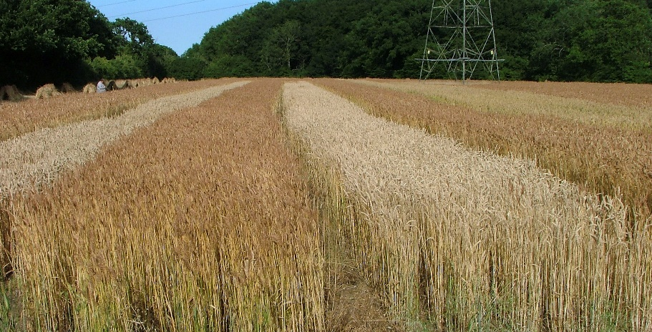 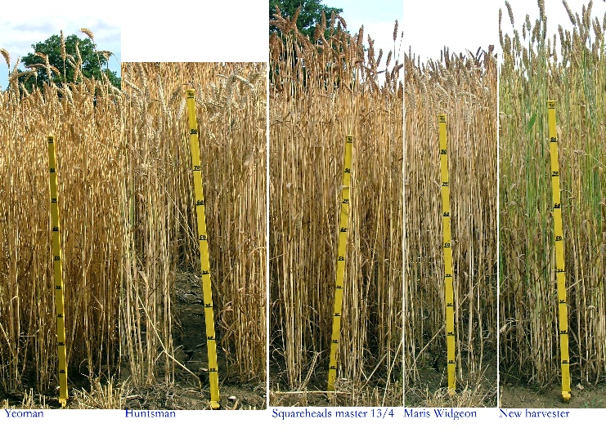 I must point out the very green variety, New Harvester, I obtained that seed from our visit to the John Innes Centre, our President and the man I like to call our scientific officer Mike Ambrose was in charge at the time, he allowed me two ears to grow on. I was attracted to the fact that this variety matured a whole week later than almost all other wheats in the field thus allowing us to spread the harvest out so as to cut the crop when perfectly ripe. Stephen letch then put in a lot of effort to thatch panels using the straw from each variety which were then erected on to sixty foot of shipping container for analysis. The first year being very detailed moisture readings at measured depths on each variety and growing condition. The roof will continue to be monitored for a further twenty years to see if there will be a difference between the different panels.
As a farmer growing straw for used as thatch I find the project very interesting, will one variety be better than another? Will no nitrogen versus high nitrogen make a difference? Time will tell.
I’d like also to do further research covering time of harvesting and thatch longevity. Early cut cheesy ripe grain and green knots versus over ripe late cut straw. Sometimes in a wet year the crop just can’t be harvested at its optimum time and so has to be perhaps a bit late in cutting.
The aims of the NTSGA were set out to benefit the thatching craft by us growers doing their utmost to provide a top quality product. Of course farming is very reliant on the season/weather, I can remember wet years where the grain “shot” on the shock and years like last year where it was almost too dry, but we carry on doing the best we can.
Amongst those aims are items which have been mentioned already today, promote, support, lobby, commitment, encourage, explore, develop and increase. Andy earlier on talked about the future with regard to machinery, we cover exactly that point. The NTSGA has been thinking about this since its inauguration. With Historic England and Andy Scarlett’s research perhaps we can delve deeper into the subject, although the old kit will probably go on for a lot longer yet. Thatched roofs though will hopefully be around for centuries to come.
We think that employment and education are important because nearly four in 10 UK farmers are over the age of 65, with an average age of 59. We need young blood to come in and learn. My son is almost 35 and he will carry on but it is a labour intensive business, and help is needed on certain days.
There is of course a crossover with thatchers, one or two of our aims appear more for thatchers rather than for growers but it is in both our interests to support regional conservation etc. Historic England would prefer “like for like” thatch on listed buildings, so would local councils, so as growers we should endeavour to support that outcome.
After the very wet Autumn of 2019 where we and others had difficulty in drilling as much winter wheat as we would have liked, I encouraged machinery enthusiasts, those people who perhaps cut an acre or two of modern wheat just for demonstration purposes at steam rallies etc. to plant a suitable thatching quality variety in order to provide a tonne or two of straw for thatch. I explained that it would be in their interest to do so financially and provide them with a more authentic show. Another aim then, to increase straw production, is important even if only by a few acres, new growers though, should not take on more than they could cope with in order to maintain quality. We can help with advice for novices if they want to get started by putting experienced growers in touch with newcomers. Maybe straw combers could receive harvested sheaves from growers who can only do the growing part of the process.
We are currently exploring ways to help people get into growing, a video is being prepared for the NTSGA website and YouTube, that covers longstraw but combed Devon reed needs a video too, we’re hoping that some of our west country friends could arrange that. I know Stephen Letch has some ideas which he will expand on at the A.G.M.
I confess that my knowledge of combed wheat straw is limited, I first saw a reed comber at work on the TV programme Old Country presented by Jack Hargreaves, I was still at school then but I remember it well. Many years ago a small group of us farmers and a Suffolk threshing contractor visited a farm near Exeter to see a comber in action, quite an impressive day it was. I want to say I think that our membership includes fewer people who use a comber than drum threshed longstraw, I may be wrong in that but it is important to include everyone who produces a quality product for thatch within the Association and combed straw is just as important as longstraw. I would like to see a good representative mix of both types of grower on the committee.
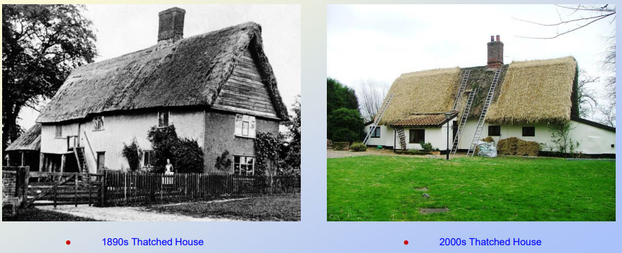
I think the future of thatch is promising, here is a picture taken in 1890 of a thatched house, since demolished, alongside a picture of a house being rethatched. They look pretty similar 115 years apart. I hope and believe that in 115 years time and beyond, thatched roofs will still feature in our landscape and that maybe many new builds will have thatched roofs too.
Since the COVID pandemic curtailed travel and meetings, I’m sad to say that we are without a Secretary so admin has become a bit slack. However! Our A.G.M. is coming up on the 22nd of this month and I’m hoping that there will be a large turnout of existing members and new members who I know will be keen to set the ball rolling again with fresh ideas for the future. There is such a lot that can benefit growers of both persuasions with a group such as the NTSGA.
Now, as chairman of the NTSGA I took on the position because I as chairman I could delegate tasks to others, if there are any questions I have two people in the audience that are probably more qualified than I to answer them. A chairman’s privilege.
Thank you.

