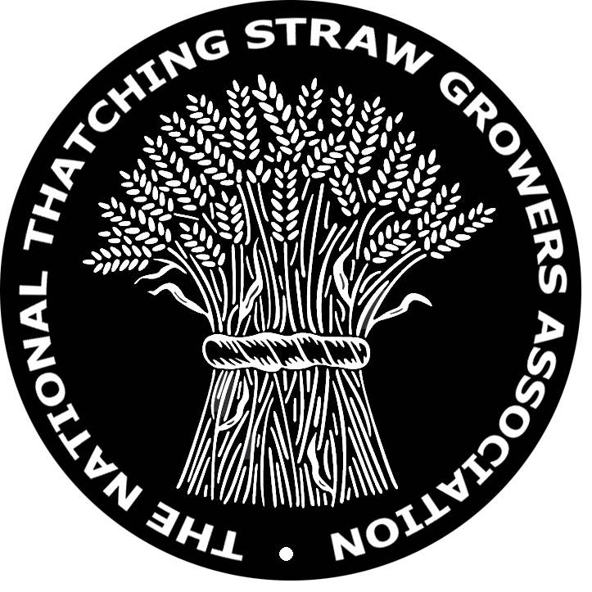

National Thatching Straw Growers Association

AGM 2015

Minute of the National Thatching Straw Growers Association AGM held at Wakelyns, Elm Farm, Fressingfield at 2:00 pm on Thursday 3rd December 2015.

Present; Mike Ambrose, Stephen Letch, Keith Dunthorne, Martin Wolfe(Wakelyns), Karen & Ed Carr, Dick Culley & Michael, guests with Graham Kirk, Graham Borrill, Chris Thomas and Robert Foster,.

Meeting started at 2pm
1 - Apologies; J.Pawsey, N.Bunce, A.Marriott & A.Broad.

2 - 2014 Minutes proposed as being accurate by Mike Ambrose, seconded by Chris Thomas.

3 - Matters arising Breeam not really of benefit so not being pursued.
Thatch guidance not complete. Thatch fires assessment still waiting – Fire Protection Assn. Have produced a document ‘ Fires in Thatched properties with open fires & Wood Burning Stoves’ will be discussed with interested parties on December 17th and will hopefully be published shortly.
Committee meeting 21/3/15 read out. Widgeon, Huntsman are registered. 13/4, New Harvester & Yeoman are now in the process of being registered with the Plants Varieties Rights Office as conservation varieties. Minutes approved as being accurate.

4 - Thatching Straw research project – 2 years of crop trials. High & low input and residual, following beans. Now onto conclusions from these trials, currently in draft form. Chris Wood from Historic England is now going through it. All varieties have produced good straw – a healthy crop at the end is important. No organic plots so inputs of fungicides not being recorded – differences therefore not being noted. Hopefully conclusion done in the next few weeks then the next phase of the money will be released & the frames can start to be positioned at Paul Watkin’s. The Ntsga to monitor the frames for 20+ years for wear & decay, noting the differences between the different husbandry & thatching techniques. 4 monitoring visits a year. The cost of this was not included within the original budget and will be extra.

5 - Martin Wolfe, of Wakelyns, then gave a presentation of his work & involvement with developing seed from trial to large scale production. Early in his career, he realised that growing mixed varieties together reduces the ability to spread disease because the average distance between each plant is larger than in a monoculture. Slowing down of the rate of disease grew exponentially in the 70’s but distrust developed with the brewers, bakers & millers not trusting as to what was included within the mixture. In East Germany, by the end of the 80’s spring barley malting harvest was all a mixture. Fungicides from the West were too expensive, so the mixture varieties nearly eradicated mildew so fungicides were not needed. After the Berlin wall came down in ’89 Dutch & West German farmers moved into the east and then the variety mixtures were replaced by a monoculture. More diversity leads to fewer biological problems, conventional agriculture driven by massive monoculture needs massive input to create the environment necessary for growth.
Variety mixtures are a step forward in disease control but organic creates a different set of problems, weeds, climate etc.. DEFRA came up with funding in 2001 for wheat populations. 20 varieties of high yield & high quality were crossed and hybridised to produce F2 seed. Nature selected the best plants best adapted to soil & climate. Competition makes the populations uniform. The EU won’t allow mixtures to be sold, so this was taken to Brussels and there is now a temporary 5 year marketing licence to see how they fare in large scale production. Seed should be available from next year’s harvest.
6 - postponed.
7 - postponed.

8 - Secretaries report - not too busy other than crop trials. 3 new members this year & 3 have left. There are now 21 Full Members & 8 associate members. Various web enquiries. 2014 AGM minutes to go on website.
9 - Chairman’s report - covered in previous items.
Treasurer’s report - £5219.45 of which £629 is NTSGA funds, the rest allocated to English Heritage project. 4 Full Members still to pay this year’s subscription.

AOB Can’t buy rat bait after June 2016 unless you are ‘certificated’. To run our own course, at a cheaper rate, 8 people are required. Any interested parties to contact K.Dunthorne.

10 - Election of Officers
President - Mike Ambrose- all agreed
Chairman – Stephen Letch – all agreed
Vice Chairman – Nigel Bunce - provisional
Secretary – Stephen Letch – all agreed
Minutes Secretary – Keith Dunthorne – all agreed
Web Secretary – Keith Dunthorne – all agreed
Treasurer – Chris Thomas – all agreed

Meeting closed at 5;30pm

