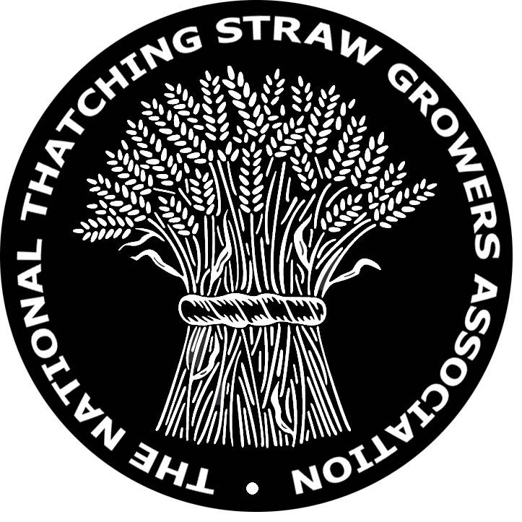

National Thatching Straw Growers Association

Minute of the National Thatching Straw Growers Association AGM held at Common Leys Farm campus, Pitts Lane, Hailey, Whitney, Oxfordshire, OX29 9UU on Saturday the 21st May 2011, which started at 2pm.

Present; Mike Ambrose, Matt Williams, Stephen Letch, Paul Watkin, Gavin Coleman, Alan & Antony Smith, Robert Hembrow, Tom Jeanes, Nigel Bunce, Graham Borrill, Chris Thomas, Graham Kirk, Robert & John Foster, Brian Bevin, David Bragg, Wendy & Mike Barns, Andy Bowman, Ray Dullen, Nigel Brown.

Apologies; Edd Carr, Stephen Shelley, Jonathon Cousins, Keith Dunthorne, Brian Gerit, Simon Deakin, Mr Cole and Alan Jones.

Meeting started at 2pm

Presentation by the NTSGA President; Mike Ambrose.
Mike Ambrose gave a short powerpoint presentation on the function room screen, which explained the reasons for the formation of the NTSGA, he also ran through the aims of the association and the benefits of pursuing them, all of which helps the industry and its growers have a strong voice.

Nigel Bunce asked about the availability of seed from John Innes for growers to sow and try out.

Mike Ambrose replied that there is the offer of samples of seed; up to 100gm for growers to bulk up. He also offered seed storage at John Innes of 500- 1000 gm to association members for safe keeping for up to 30 years. This would be an informal agreement, those interested to write to Mike Ambrose.

Treasurers Report; Dominic Meek could not make the meeting but reported that a NTSGA account had been set up finally with the Co-Op bank, present funds in account £421.00
Application fees are still coming in. Treasurer to post out receipts for subscriptions/fees.

Chairman’s Report; Matt William explained how the association was formed and how important this new body was needed to give a voice nationally to promote thatching straw and its growers.
Initially the founder members of 12 growers met up in Suffolk on the 27th September 2010, where a name was decided on and what sort of aims & principles it should include, a draft constitution was to be drawn up and presented for comment and possible acceptance at a following meeting at The Kings Head, Laxfield, Suffolk on the 11th January 2011.
At this meeting the constitution was ratified and fee’s set, with the decision to have a AGM in May of 2011 somewhere in the middle of the country with invitations sent out to as many known growers though out the UK as possible inviting them to apply to join the NTSGA and attend the AGM.

Secretaries report; Stephen Letch reported that to date the NTSGA had 20 members, quite a sizable group of growers, he also mentioned that around half a dozen people have said they will join and that he’s awaiting their completed application forms. He asked members to be patient on the paperwork side, as the caretaker committee are still finding its feet.

Brian Bevin raised the possibility of over production of thatching in the future, if a sizable number of new growers are encouraged to enter the market.
Matt Williams said that thatchers import approximately £20 million worth of reed and straw, if home grown straw is marketed and promoted in the right way it could take a sizable chunk of business away from the importers, together with promoting new build and reinstating thatch using home grown straw should ensure there is not a problem with over production for the foreseeable future.
Paul Watkin agreed.
Graham Kirk felt strongly that much more could be done to promote sustainable new build thatch using local materials.
Matt Williams said that the more information we can get out there in the public domain the more informed the clients, architects, planners and developers will be to make a wise choice and go with good home grown straw thatch.
Robert Foster stated the importance of good quality and suitable thatching straw to be the backbone for a drive to get straw thatching to be taken seriously and to build up the whole industry for a healthy future.
Nigel Bunce felt that as a thatcher first, the quality of the thatching straw was most important to help him carry out good thatching work, being a grower also helped him achieve this goal.
Ray Dullen said he was competing in a price war, with stripper header cwr and imported water reed being cheaper than his labour intensive traditional production of cwr.
Matt Williams responded by reiterating that we (NTSGA) need to get the message across to conservation/planning departments and thatch owners that good quality home grown sustainable thatching materials are available.
Action…
Tom Jeanes said it would be a good idea to have a register of materials available and our grower members .
Brian Bevin stated that through hard times, an Association is important to lobby and push itself to the forward in the pubic eye and achieve benefits, there is no strength as individuals alone.
Chris Thomas said the register of thatch materials could be posted on the website.
Action….
Ray Dullen returned to the problems he has in Devon feeling despondent that water reed was replacing CWR on many cottages and felt at a loss as what he or any association could do about it.
Matt Williams pointed out that there were regional differences as to how well conservation officers do their job, Devon seems to have its problems on this front where as East Anglia has minimal problems.
Stephen Letch confirmed that in East Anglia the problems of this kind are contained, the East Anglia Master Thatchers Association keeps the conservation departments informed which helps keep the officers focused on the need to keep the tradition of Long Straw thatching healthy along side the traditional water reed areas of the broads and estuaries.
Mike Ambrose said we must get together all our key issues to take as a mandate to the highest level and prepare a half page article for the national papers.

Gavin Coleman suggested that the NTSGA could look into some relationship with a college for the purposes of mentorship in learning specific husbandry skills that the growing of thatching straw requires.

Election of Officers

Chris Thomas thought that it was important that regional representation was present in the committee of officers of the NTSGA.

Chairman; Matt Williams
Proposed by Paul Watkins and seconded by Mike Barns.

Vice-Chairman; Nigel Bunce
Proposed by Robert Hembrow and seconded by Dave Bragg.

Secretary; Stephen Letch
Proposed by Tom Jeanes and seconded by Robert Foster.

Treasurer; Dominic Meek
Proposed by Chris Thomas and seconded by Dave Bragg.

Web- Secretary; Keith Dunthorne
Proposed by Graham Borrill and seconded by Matt Williams
Everyone present was happy to have Mike Ambrose continue as the NTSGA president.

Meeting closed at 5.00pm

Actions as a result of the meeting;
- Names, addresses and contact details of member growers to be listed on the website together with the type of thatching straw produced and it’s variety name.
- A NTSGA press release to be compiled and released nationally.
- Mike Ambrose to compile crop/thatching straw husbandry records received from members.
- Have a web page for wanted/for sale items, and a page for technical information such as machinery manuals etc that members may find useful, this suggestion has been made by a couple of member growers.

Possible other action suggestions;
- To have a members only forum set up through the web site that is password protected, this would enable ideas to be discussed and if necessary acted upon quickly without waiting for meetings of members from long distances apart.
- Secretary to converse with LANTRA for possible link up and help with promoting the NTSGA and its aims.

Please contact the secretary with your thoughts concerning these two suggestions.

Yours sincerely

Stephen Letch
Hon. Secretary

